2021Winter CIS200 – Programming Assignment 1

Class, Inheritance and UML

Professor: Jie Shen

Release date: Feb 1, 2021

Due date: Feb 14, 2021

Student name: Demetrius Johnson

Contents

**Question 1 - Inheritance (30 points)** 3

Source code (USED C++ COMPILER on Microsoft Windows 10) 3

Test data and expected results 3

TEST 1: 5

TEST 2: 5

TEST 3: 6

**Question 2 - Class (30 points)** 7

Source code (USED C++ COMPILER on Microsoft Windows 10) 7

Test data and expected results 7

TEST 1: 8

TEST 2: 8

TEST 3: 9

TEST 4: 9

**Question 3 (15 points)** 10

**Question 4 (15 points)** 11

# **Question 1 - Inheritance (30 points)**

## Source code (USED C++ COMPILER on Microsoft Windows 10)

See CPP and H uploads I made in canvas with this document along with the executables.

## Test data and expected results

Test Table:

|  |  |  |  |  |  |  |
| --- | --- | --- | --- | --- | --- | --- |
| Test # | Valid / Invalid Data | Description of test | Input Value | Expected Output | Actual Output | Test Pass / Fail |
| 1 | valid | Used set and get functions for x | age = 3, price = 200 | age = 3, price = 200 | See screenshot | pass |
| 2 | valid | Used set and get functions for y | age = 2, price = 300, appleID = 1234 | age = 2, price = 300, appleID = 1234 | See screenshot | pass |
| 3 | valid | Used set and get functions for z | age = 1, price = 500, appleID = 3234  AugmentedRealityStatus = 1 (true) | age = 1, price = 500, appleID = 3234  AugmentedRealityStatus = 1 (true) | See screenshot | pass |

1) Draw three UML class diagrams, one for each of the classes mentioned above.

2) Draw a generalization among the three class diagrams, showing the inheritance relationship.

Note: for the above two parts I combined them into one diagram:

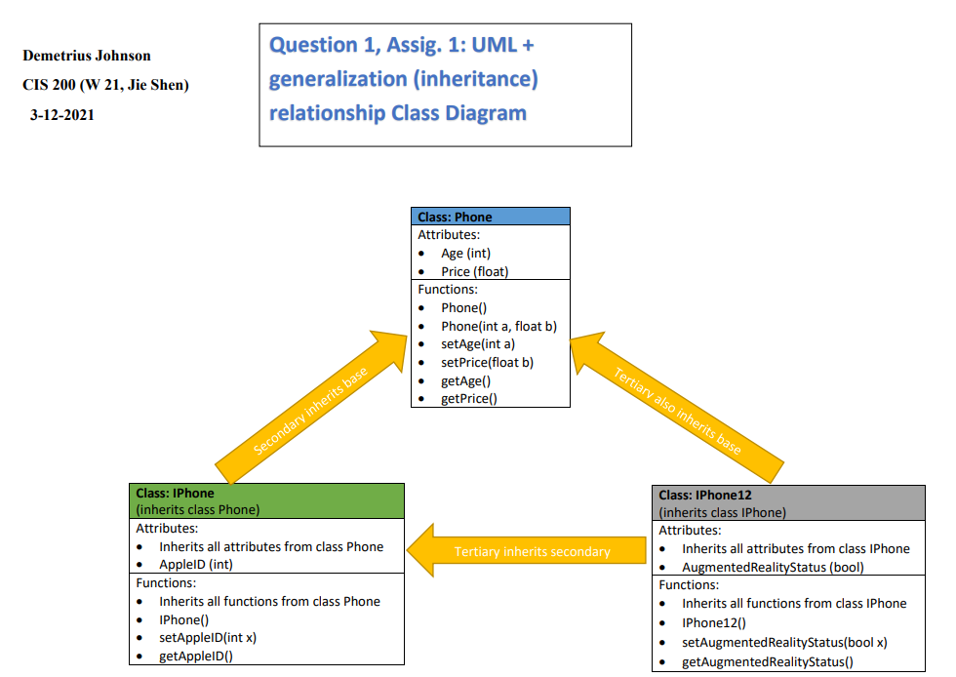

3) Implement the main driver function to test classes and test input:

### TEST 1:

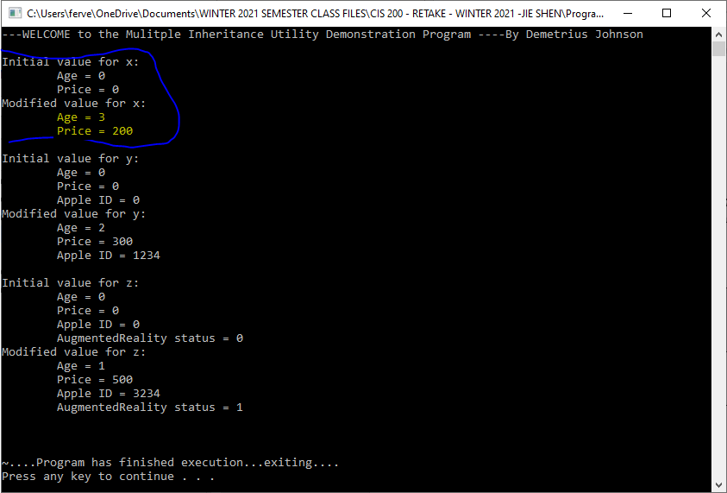

### TEST 2:

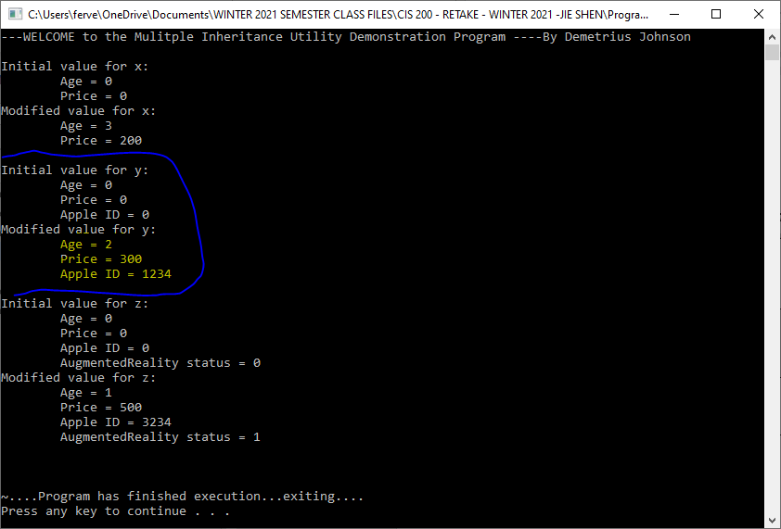

### TEST 3:

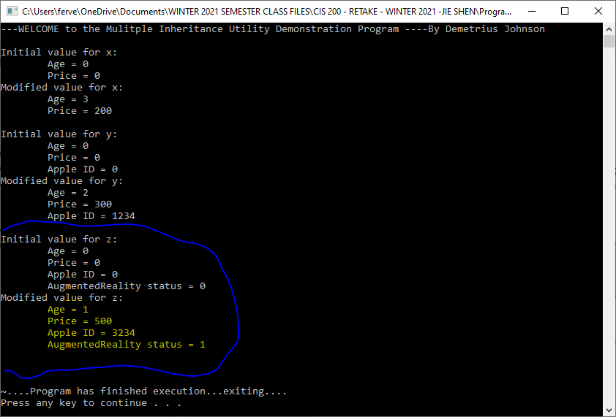

# **Question 2 - Class (30 points)**

## Source code (USED C++ COMPILER on Microsoft Windows 10)

See CPP and H uploads I made in canvas with this document along with the executables.

## Test data and expected results

Test Table:

|  |  |  |  |  |  |  |
| --- | --- | --- | --- | --- | --- | --- |
| Test # | Valid / Invalid Data | Description of test | Input Value | Expected Output | Actual Output | Test Pass / Fail |
| 1 | valid | Original values of a, b, c, and d | Construct a-d obejects | See screenshot | See screenshot | pass |
| 2 | valid | Use copy constructor | Employee e(a); | See screenshot | See screenshot | pass |
| 3 | valid | Use assignment operator= | d = b; | See screenshot | See screenshot | pass |
| 4 | valid | Output contents of d and e to a file | Used print(ostream&) function | See screenshot | See screenshot | pass |

### TEST 1:

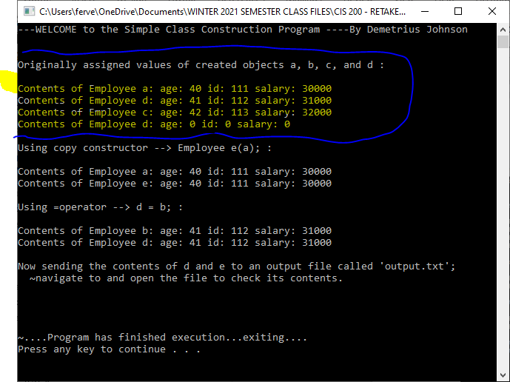

### TEST 2:

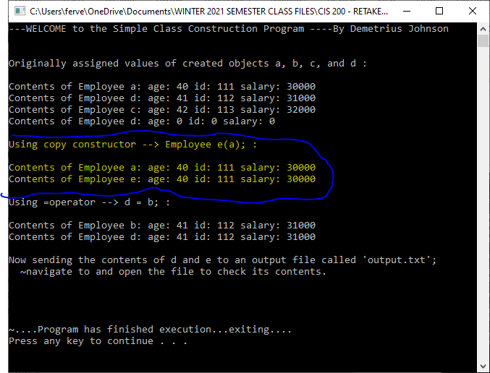

### TEST 3:

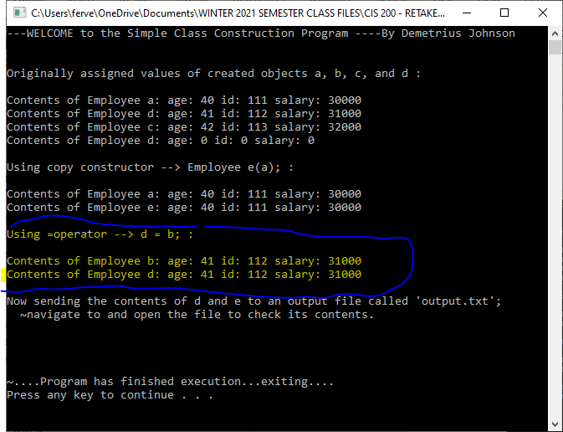

### TEST 4:

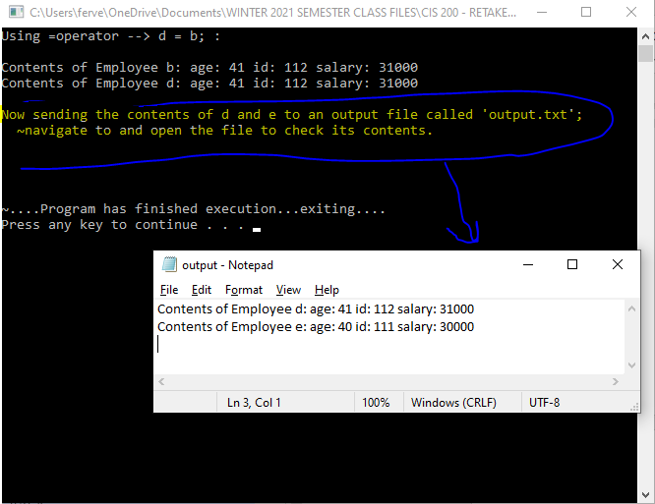

# **Question 3 (15 points)**

If we change our mind by using a struct to represent the information in Question 2, give the definition of a struct that you would like to use.

*I would use a struct such as this, remembering that by default all members of a struct are public:*

*struct Employee{int age; int id; float salary;};*

*\*I would not need any set or get functions since all of the members are accessible to all other functions. This would make programming question 2 a lot easier!*

Answer the following questions:

1. Do we need a constructor or a destructor in a struct? Why?

*We do not need a constructor or destructor since the struct would simply use non-pointer variables and will do just fine using the implicit default constructors and destructors.*

1. Do we need those get and set member functions in a struct? Why?

*No; all member functions a struct is by default public (which are unlike classes that by default set all members private).*

1. Can we have a member function in a struct? Give an example.

*Yes, we can have a member function in a struct. For example, you may have a print function that can output the contents of the struct to a file, or maybe you could have a reset function that will set all values in the struct to some default value through one function call.*

1. Between class and struct, which one is light-weighted (i.e., with less overhead)?

*Struct definitely has less overhead as typically a struct is used so that a programmer does not have to write as many class functions, also because usually all members can be accessed directly and there is no need for as many functions with return values – return values come from functions whose local variables are placed on the stack, hence, there is overhead for the function call.*

# **Question 4 (15 points)**

Construct a Use Case Diagram of Student on the basis of the following specification:

Four Actors: Student, Registrar, Teacher and Financial Institution

Four Use Cases:

(1) Register a UM-D course: invoked by Student and handled by Registrar

(2) Drop a UM-D course: invoked by Student and handled by Registrar

(3) Attend a UM-D course: invoked by Student and taught by Teacher

(4) Obtain a student loan: invoked by Student and handled by Financial Institution

